Diary Week 2

The task that we were assigned to do was create a game based around territorial acquisition. The game idea that we went with was a tile-based game that was situated on a board.

Premise:

The way you play the game is each player has four tiles each and you each player has to try to gain control over as much tiles as they can within the set amount of turns that have been set. Player can draw cards from the deck that can either benefit them or hinder them in a way and these cards can be held onto and used at any point with a few exceptions. The game will end when either one player has gained control over all available points on the board or when a set number of turns have passed and the winner is deemed by whoever has the most points in the end. The man objective of the game is to gain as much points as you can by the end of the game and this can be done through various ways for example, working with other players. The pieces that come with the game are:

* 2 dice
* 16 player tiles (four different colours)
* 1 dotted game board
* 64 cards
* Notepads and pencils

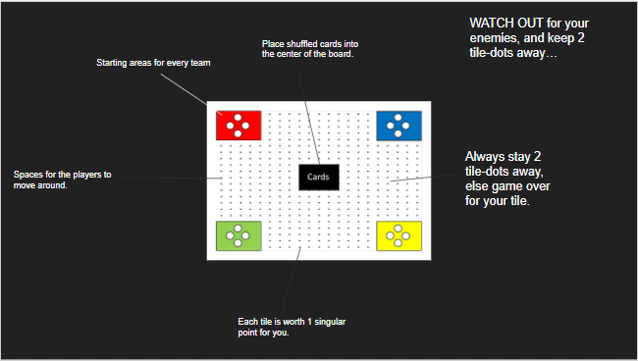The board:

This is what the board itself looks like and there are four areas in each corner where each participating player will place their tiles in and where they start from. Each tile within the dots are worth one point and they can be stolen by another player at any given point. In the middle is where the deck of cards is placed once they have been shuffled.

Game rules and mechanics:

The rules of the game are that each player will place their tiles in their respective places and each player will roll the dice in turn to see who will go first. The player who rolls the highest number goes first and then in descending order. Once the turn order has been sorted out, players must roll the dice onto the board and make their way around the board, collecting points as they go along. Players can pick up cards as they are traversing through the board and these cards can be either good or bad depending on what is written on them and players can choose to keep the card in their hand or trade them with another player in exchange for points or a card of similar value. Players must stay two blocks away from another player in order for them to be safe and if they fall with the two block space, then they could potentially lose some points or be eliminated by another player and reset their progress back to zero.

The mechanics of them game consists of a point system. This system is how players can compete for the number 1 spot and this is how players gain points as they play. The cards are another mechanic of the game as they can be advantageous for the player that acquires them. In addition to this, they can also be disadvantageous. The trading system allows players to trade cards that they have in their possession for point or for a different card of the same value or more.

Through playtesting, some issues have been noticed. While the game runs smoothly, the cards that were in the game were very basic and could have been better. There was not much of a variety in what the cards offered.